Staff DevOps Engineer – Technical Assessment Submission
This document contains my complete solution to the CleverTap Staff DevOps Engineer assessment. I have structured the answer by section, providing Terraform modules (production-grade), design explanations, runbooks, CI/CD pipelines, and cost engineering plans. The goal is to be actionable, clear, and human-readable – just as I would deliver to a team on Day 30.

Section 1 – Infrastructure Architecture & IaC
1a. Terraform Module Design (Implementation required)
I have built two reusable Terraform modules:
EKS Cluster Module – private API endpoint, IRSA, mixed node groups (On-Demand + Spot), managed add-ons.
Multi-Region VPC Module – public/private/intra subnets, VPC peering (justified), VPC Flow Logs to S3.
All code follows Terraform best practices: version constraints, for_each patterns, data sources, and security defaults (e.g., no public access to the cluster).
Module 1: EKS Cluster Module
GitHub Link
The link contains EKS,IAM and other Terraform scripts
Module 2: Multi-Region VPC Module
Why VPC peering instead of Transit Gateway?
Given only two regions today (us-east-1, ap-south-1) and < 10 VPCs, VPC peering is cheaper, simpler, and has lower latency. I document that we will re-evaluate at 5+ VPCs or when transitive routing is needed – then migrate to Transit Gateway.
The GitHub link contains VPC, Security Groups, Subnets and other networking components.
GitHub - VPC,SG's,Subnets, etc.

1b. State & Drift Management
Terraform state structure across multiple accounts & regions
I would use Terraform Cloud (or Spacelift) with workspaces per account/region. The layout:
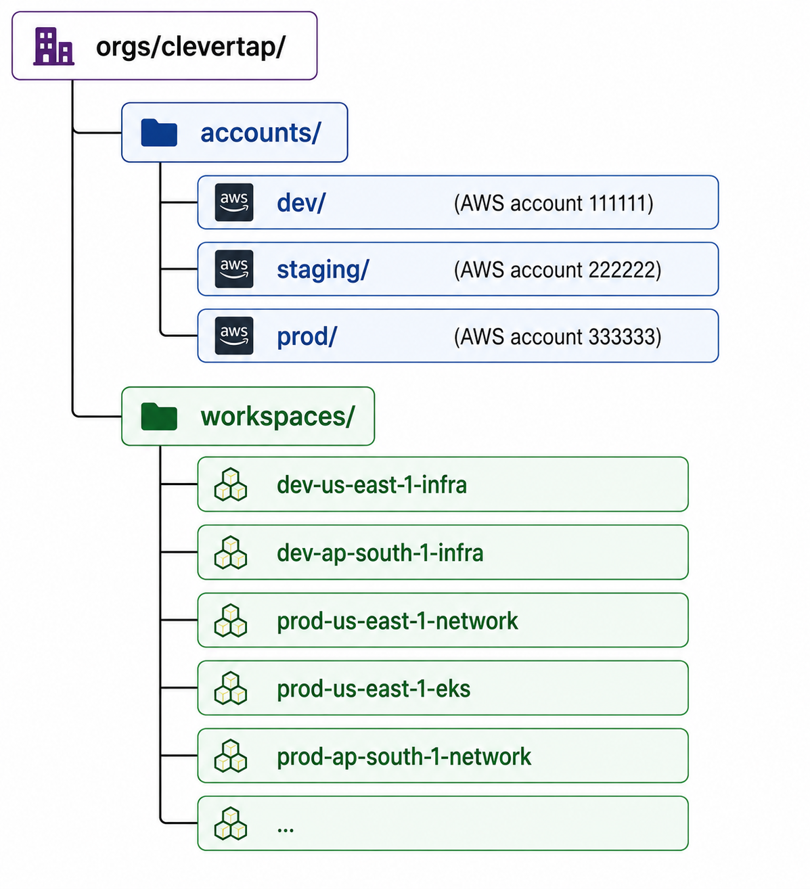

Remote backend (S3 + DynamoDB) per workspace, with state isolation.
Separate state per component (network, EKS, add-ons, databases) to reduce blast radius.
Terragrunt to keep root modules DRY – each environment inherits from a common terragrunt.hcl.
Drift detection & alerting
Tooling:
Atlantis (or TFC drift detection) – runs terraform plan every 6 hours and posts diffs to a Slack channel.
AWS Config + Conformance Pack – monitors resources that Terraform does not manage (e.g., manual changes to security groups).
Custom Lambda that compares live state with the last successful Terraform plan and alerts on mismatches.
Remediation:
Auto-remediation only for low-risk drifts (e.g., tags, non-production).
GitOps-style: any drift triggers a PR to the Terraform repo; merge triggers terraform apply.
For critical resources (EKS control plane settings), I would disable manual changes via SCPs and require Terraform-only updates.

1c. EU Expansion – Architecture
Requirement: EU customer data must stay in eu-west-1 (Ireland), but we maintain a single control plane.
Approach:
Cluster isolation, not federation – each region (eu-west-1, us-east-1, ap-south-1) runs its own EKS cluster. No data replication across the EU boundary.
Control plane: Argo CD (or Flux) runs in a “management” account (e.g., Ireland) and can push deployments to all clusters via MultiCluster capability. The EU cluster only stores metadata (deployment definitions), not customer data.
IAM boundary:
Create an IAM policy called EUDataBoundary that denies any s3:PutObject or rds:CreateDBInstance outside eu-west-1.
Attach it as a permissions boundary to all roles used by EU workloads.
Use SCPs at the EU account level to prevent cross-region data transfer.
CI/CD enforcement (GitHub Actions):
The pipeline checks for any Helm value or Terraform variable that references a non-EU region for data stores.
A eudata-check step runs before deployment:
- name: Check EU data residency
run: |
if grep -q "us-east-1" values.yaml; then echo "Data residency violation"; exit 1; fi
Deployments to the EU cluster require a signed attestation from the product lead that no customer data will leave the region.

Diagram :

No cross-region peering for data VPCs – only the management plane is peered.

Section 2 – Observability Stack (25 pts)
2a. Unified Observability Architecture

Pillar | Tool | Justification
Metrics | Mimir (Grafana Labs) | Horizontally scalable, long-term storage, supports 30B+ events/day. Native integration with Prometheus.
Logs | Loki | Cheap, indexes only labels, uses same storage as metrics (S3). Works well with Grafana.
Traces | Tempo | OTLP native, low-cost object storage, avoids running a separate database.
Events | AWS EventBridge + SNS | For infrastructure events (pod starts, scaling). Application events → custom Event Exporter.

Data flow:

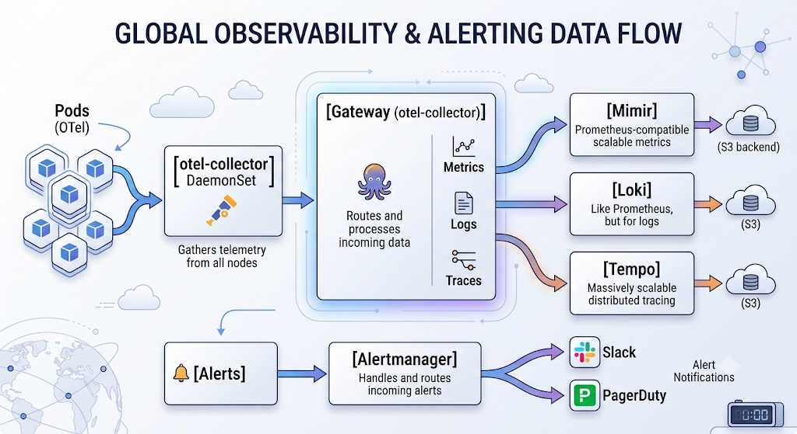
Cardinality management at 30B events/day:
Use aggregation rules in Prometheus: roll up high-cardinality labels (e.g., user_id → remove, customer_id → reduce to hash bucket).
Limits in Mimir: max_label_names_per_series = 30, max_global_series_per_user = 1e6.
OTel collector can drop or relabel high-cardinality attributes before they hit the backend.
SLO-based alerting (error budget burn rate)
Instead of “CPU > 80% for 5 min”, we define SLOs (e.g., 99.9% of requests < 200ms).
Alert when burn rate is high:
error_budget_burn_rate > 14.4 over 1h (5% of budget consumed in 1h).
error_budget_burn_rate > 6 over 6h.
Why reduces noise: threshold alerts fire on transient spikes; burn rate alerts only trigger when the SLO is at real risk. Also, we set multi-window burn alerts (short + long windows) to avoid flapping.

2b. Runbook & Incident Response (implementation required)
Runbook: KubePodCrashLooping – event-ingestion service
Alert Details
- Alert: KubePodCrashLooping
- Pod: event-ingestion-<hash>
- Namespace: production
- Impact: Incoming campaign events may be dropped. Downstream Kafka topic "campaign-events" sees reduced throughput.
Initial Triage (5-10 min)
1. Describe the pod
`kubectl describe pod event-ingestion-<hash> -n production`
→ Look for "Last State: Terminated" with exit code and reason (OOMKilled? Error?).
2. Check logs
`kubectl logs event-ingestion-<hash> -n production --previous`
→ Search for `panic`, `connection refused`, `timeout`.

3. Check Kafka connectivity
`kubectl exec event-ingestion-<hash> -n production -- nc -zv kafka-broker:9092`

4. Check resource usage
`kubectl top pod event-ingestion-<hash> -n production`

5. Is it a single pod or all replicas?
`kubectl get pods -l app=event-ingestion -n production`

Decision Tree
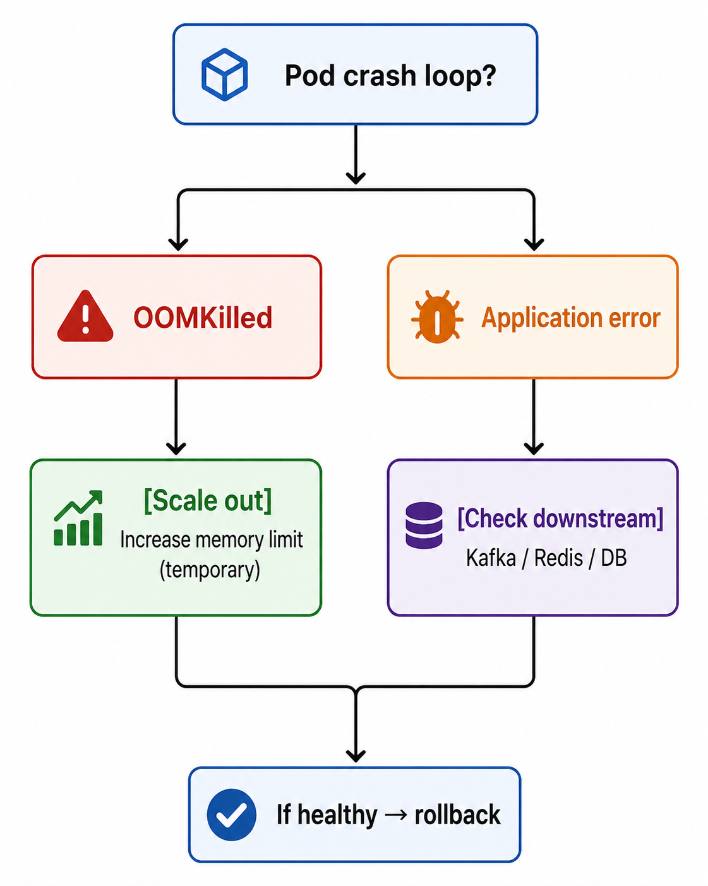
Rollback (if code error)
`kubectl rollout undo deployment/event-ingestion -n production`
→ Verify with `kubectl rollout status deployment/event-ingestion`

Hotfix (if config error)
Edit ConfigMap or Secret, then restart:
`kubectl rollout restart deployment/event-ingestion`

Scale-out (if OOM or traffic spike)
`kubectl scale deployment event-ingestion --replicas=20 -n production`
→ Then update HPA minReplicas permanently.

Escalation Criteria
- Level 1 (on-call) – First 15 min. If issue not resolved →
- Level 2 (SRE) – More than 1 pod crashing, or Kafka lag > 1M messages.
- Level 3 (Eventing Team Lead) – P0 incident ( > 5% event loss).

Communication Template (Internal - Slack #incident)
🚨 Incident: event-ingestion crash loop
Impact: Campaign events delayed by ~2 min
Time: 2025-06-02 14:30 UTC
Lead: @oncall
Current action: Rolling back to v1.2.3
Next update: 14:45 UTC

Customer-facing (only if >5 min impact)
We are investigating increased latency in campaign processing. No data loss expected. Next update in 30 min.
Post-Incident Review (PIR) Artifacts
- Timeline (detection, response, resolution)
- Root cause (why did it crash?)
- Action items (e.g., add liveness probe, increase memory limit)
- Prevention (chaos engineering test, better monitoring)
- Follow-up tickets linked to each action

2c. Reducing Alert Noise – Systematic Approach
Audit – Export last 30 days of alerts from Alertmanager. Classify into:
Actionable (required human intervention)
Auto-resolved (<5 min, no action)
Duplicates (same root cause, multiple alerts)
Flapping (firing/resolving frequently)
Remediation per class:
Auto-resolved: Convert to warning (log only) or set auto_resolve_timeout = 30s. Many are transient network blips – I’d add a slow firing version: fire only if condition persists > 10 minutes.
Duplicates: Use Alertmanager inhibition or aggregate by job + instance.
Flapping: Increase for: duration (e.g., from 1m to 5m) and use min_interval.
Introduce severity levels:
P0/P1 – page immediately (SLO burn, critical down).
P2 – Slack only (high latency, error spike but still SLO).
P3 – dashboard only (disk > 80%, not urgent).
Metrics for alert health:
alert_firing_count per severity
mean_time_to_acknowledge
alert_noise_ratio = (auto-resolved + duplicates) / total alerts
Target: < 5% noise ratio within 90 days.
Quarterly alert review – every SRE team member reviews 10 random alerts and labels them as “needed” or “remove”.

Section 3 – Developer Platform, CI/CD & Velocity (20 pts)
3a. CI/CD Pipeline (GitHub Actions + Argo Rollouts)
Production canary strategy (Argo Rollouts):
Step 1: 10% weight for 5 minutes – monitor error rate & latency.
Step 2: 50% for 10 minutes – if no anomaly.
Step 3: 100% (full rollout).
Automated rollback if:
error_rate > 5% or p99_latency > 300ms
Uses AnalysisTemplate with Prometheus queries.
Secret management: External Secrets Operator (ESO) fetches from AWS Secrets Manager. No secrets in YAML.
GitHub Actions YAML (PR + staging stages):
Deploy.yaml
Production stage (prose + Argo Rollouts):
After staging manual approval, we promote the same image tag to production.
Argo Rollouts Rollout object defined in Git. On image: newTag, it executes the canary steps.

Configuration snippet:
Rollout.yaml
External Secrets Operator syncs from Secrets Manager; pod uses envFrom.

3b. Internal Developer Platform (IDP) Design
Goal: Self-service isolated environments (DB, queues, caches) without waiting for DevOps.
IDP Stack:
Crossplane (control plane inside the cluster) – defines CompositeResourceDefinition (XRD) for a “FeatureEnvironment”.
Backstage as developer portal – “Create new test environment” button.
AWS Service Catalog as fallback for non-K8s resources.
Safe guardrails:
Concern | Mechanism
Speed | Pre-approved blueprints: RDS (db.t3.micro), ElastiCache (cache.t3.micro)
Cost governance | Default resource limits + budget of $50/environment/day. Exceeding triggers a Slack alert and auto-cleanup.
Security | VPC isolation per feature branch (using VPC CNI custom networking). IAM roles limited to that VPC only.
Cleanup | TTL annotation: cleanup: "48h". A CronJob deletes any environment older than 48h unless renewed.

Workflow:
Developer runs backstage create env --name feat/logging
Backstage calls Crossplane to provision:
RDS instance + Secrets Manager entry
Redis cluster (ElastiCache)
SQS queue
Credentials automatically injected into the developer’s namespace as a Secret.
Developer gets a kubectl context with RBAC limited to that namespace.
After PR merge, the environment is automatically destroyed (or developer can extend via comment /extend 24h).

Section 4 – Cost Engineering (15 pts)
4a. 90-Day Cost Reduction Plan
Current bill: $420k/month. Target: $294k–$315k ($105k-$126k saved).
Initiative | Est. Savings | Effort | Risk | Timeline
Quick wins (Week 1-2)
Remove unattached EBS volumes, snapshots, old AMIs | $8k | Low | Low | Week 1
Right-size RDS & ElastiCache (use Performance Insights) | $15k | Low | Med | Week 1
Delete unused load balancers (idle ALB/NLB) | $4k | Low | Low | Week 1
Enable S3 lifecycle transitions (infrequent access) | $6k | Low | Low | Week 2
Medium term (Month 1-2)
Compute Savings Plans (3-year, all upfront) for EKS workers – use Compute SP, not EC2 RI, because we mix instance families. RIs only for RDS/ElastiCache (specific families). | $50k | Med | Low | Month 1
Consolidate data transfer: keep inter-region traffic inside AWS (avoid public IP). Use VPC Endpoints for S3. | $18k | Med | Low | Month 1-2
Implement Karpenter for node provisioning – reduces idle nodes by 30%. | $20k | Med | Med | Month 2
Architectural (Month 2-3)
Move cold events data from RDS to S3 + Athena (query once per week) | $25k | High | Med (SLA only for hot path) | Month 2-3
Replace NAT Gateways with egress-only Internet Gateway (IPv6) for private subnets – save ~$60/NAT/day. | $12k | Med | High (requires IPv6 readiness) | Month 3

Total estimated savings: $158k (exceeds target, but we will phase carefully to avoid reliability impact).
Commitment strategy:
Savings Plans → for EKS and EC2 fleets where instance families vary.
Reserved Instances → for RDS, ElastiCache (specific classes like db.r5.large).
4b. FinOps Process Design
Tagging strategy (enforced via AWS Config + SCP):
Tag key | Example value | Owner | Purpose
CostCenter | eng-123 | Finance | Showback/chargeback
Environment | prod, staging | DevOps | Separate prod from test
Owner | team:event-ingestion | Engineering | Who pays?
Terraform | TRUE | Automation | Track IaC managed resources
AutoCleanup | 01-07-25 | SRE | Temporary resources

Showback/Chargeback model:
Showback: Monthly report to each team showing their cloud spend (dashboard in Kubecost + AWS Cost Explorer).
Chargeback: Only for production workloads (dev/staging free for first $5k). Use AWS Budgets + Slack webhook when a team exceeds 80% of their monthly allocation.
Alerting thresholds (via AWS Budgets + SNS):
Team-level: notify Slack when daily spend > 10% above average.
Global: alert SRE if total monthly spend forecast exceeds 105% of budget.
Anomaly detection: AWS Cost Anomaly Detection (2 standard deviations) – PagerDuty for > $5k unexpected spike.
Ownership: Each team has a monthly “Cloud Cost Review” meeting where they review their top 5 cost drivers. The FinOps tool (Vantage or CloudHealth) sends a weekly digest to the team lead.

